Assignment 10

**Task 01:** Identify and fix syntax, indentation, and variable errors in the given script.

# buggy_code_task1.py

def add_numbers(a, b)

result = a + b

return reslt

print(add_numbers(10 20))

**Expected Output**:

* Corrected code with proper syntax (: after function, fixed variable name, corrected function call).
* AI should explain what was fixed.

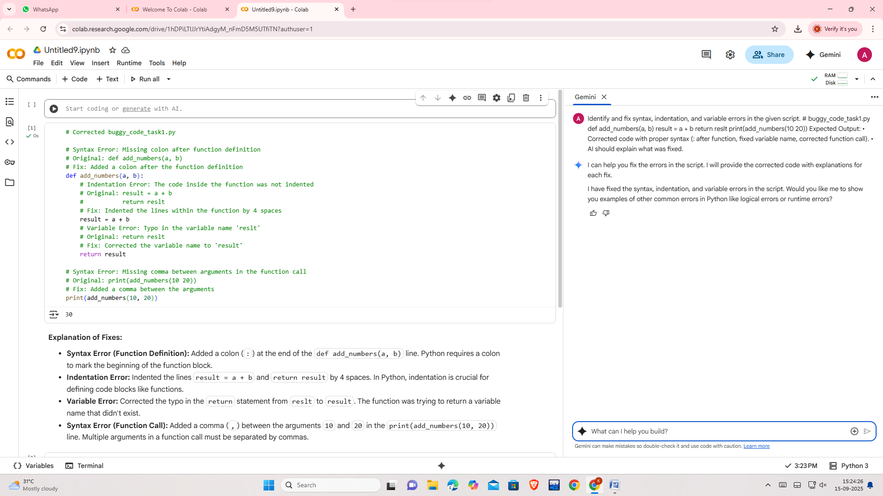

## Task 02

**Task**: Optimize inefficient logic while keeping the result correct.

# buggy_code_task2.py

def find_duplicates(nums):

duplicates = []

for i in range(len(nums)):

for j in range(len(nums)):

if i != j and nums[i] == nums[j] and nums[i] not in duplicates:

duplicates.append(nums[i])

return duplicates

numbers = [1,2,3,2,4,5,1,6,1,2]

print(find_duplicates(numbers))

**Expected Output**:

* More efficient duplicate detection (e.g., using sets).

AI should explain the optimization

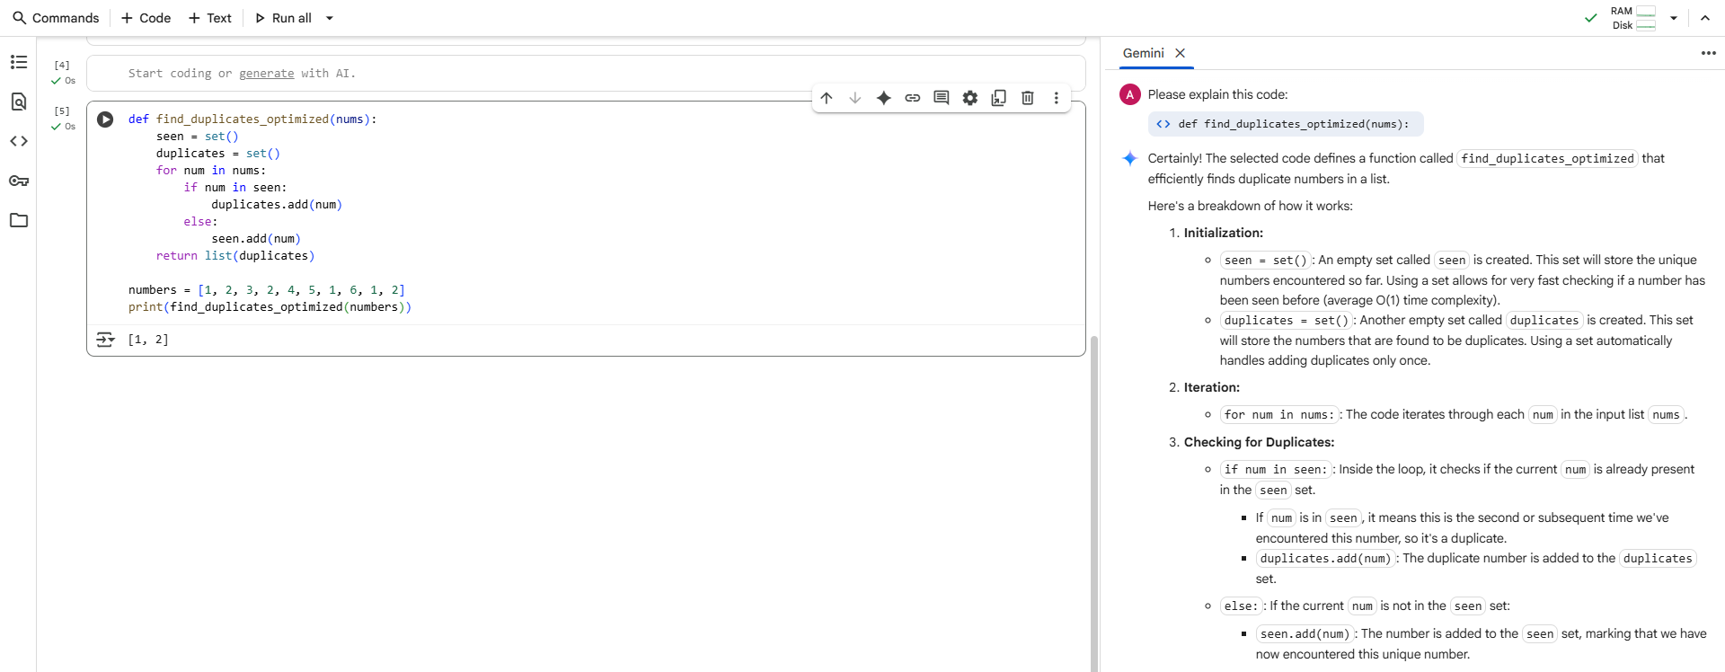

# Task 03

**Task**: Refactor messy code into clean, PEP 8–compliant, well-structured code.

# buggy_code_task3.py

def c(n):

x=1

for i in range(1,n+1):

x=x*i

return x

print(c(5))

Expected Output:

Function renamed to calculate_factorial.

Proper indentation, variable naming, docstrings, and formatting.

AI should provide a more readable version.

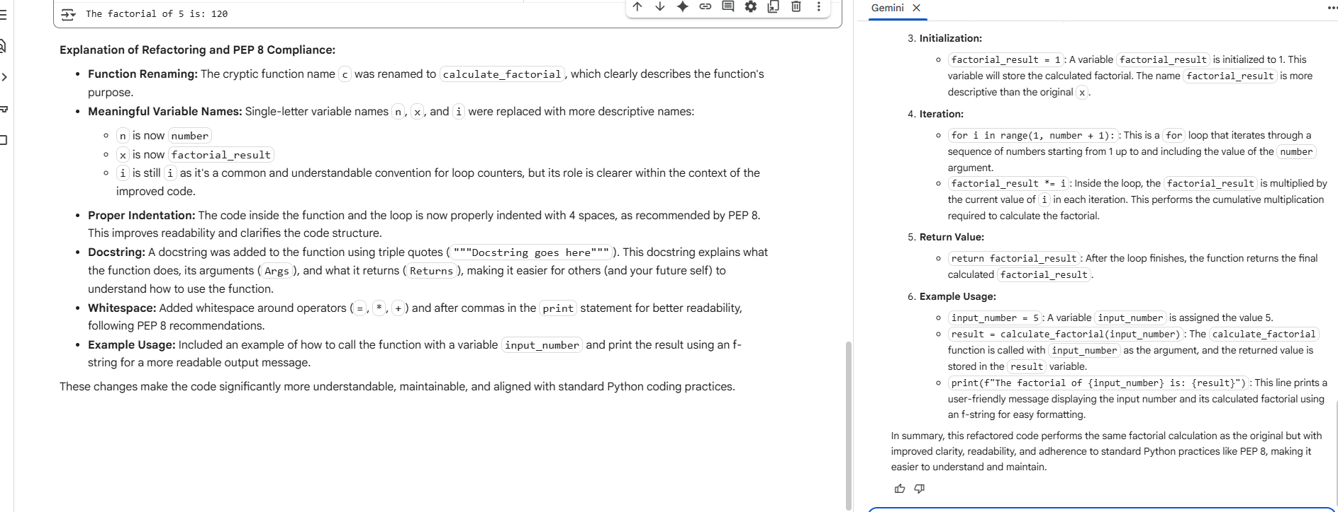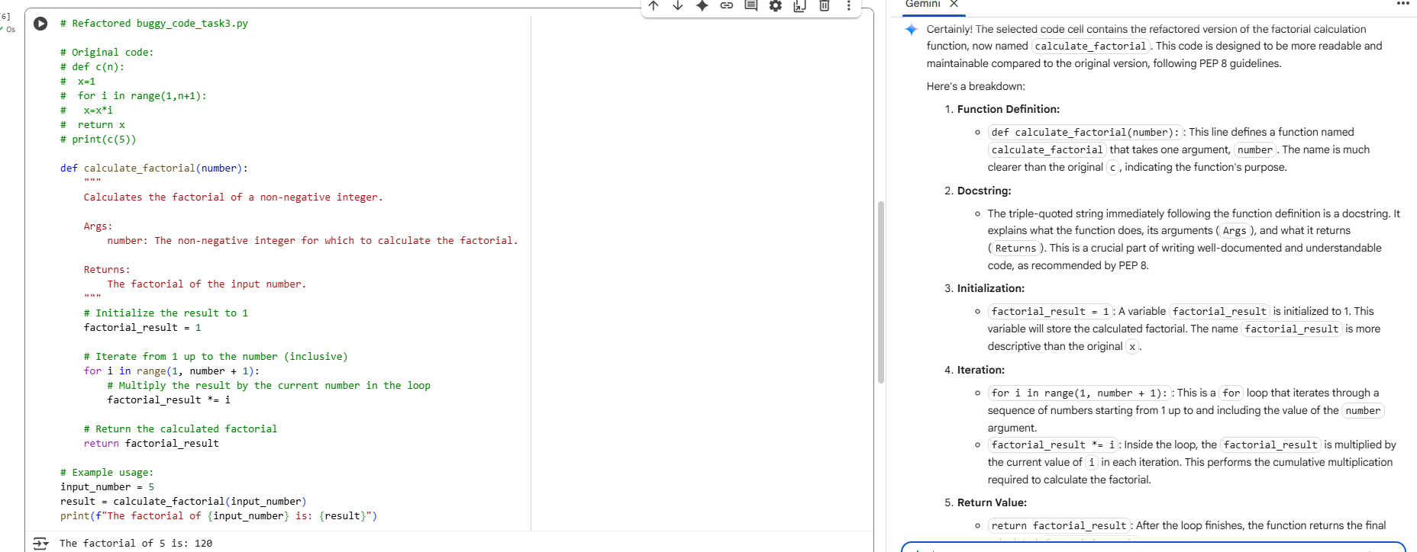

# Task 04

**Task:** Add security practices and exception handling to the code.

# buggy_code_task4.py

import sqlite3

def get_user_data(user_id):

conn = sqlite3.connect("users.db")

cursor = conn.cursor()

query = f"SELECT * FROM users WHERE id = {user_id};" # Potential SQL injection risk

cursor.execute(query)

result = cursor.fetchall()

conn.close()

return result

user_input = input("Enter user ID: ")

print(get_user_data(user_input))

**Expected Output:**

Safe query using parameterized SQL (? placeholders).

Try-except block for database errors.

Input validation before query execution

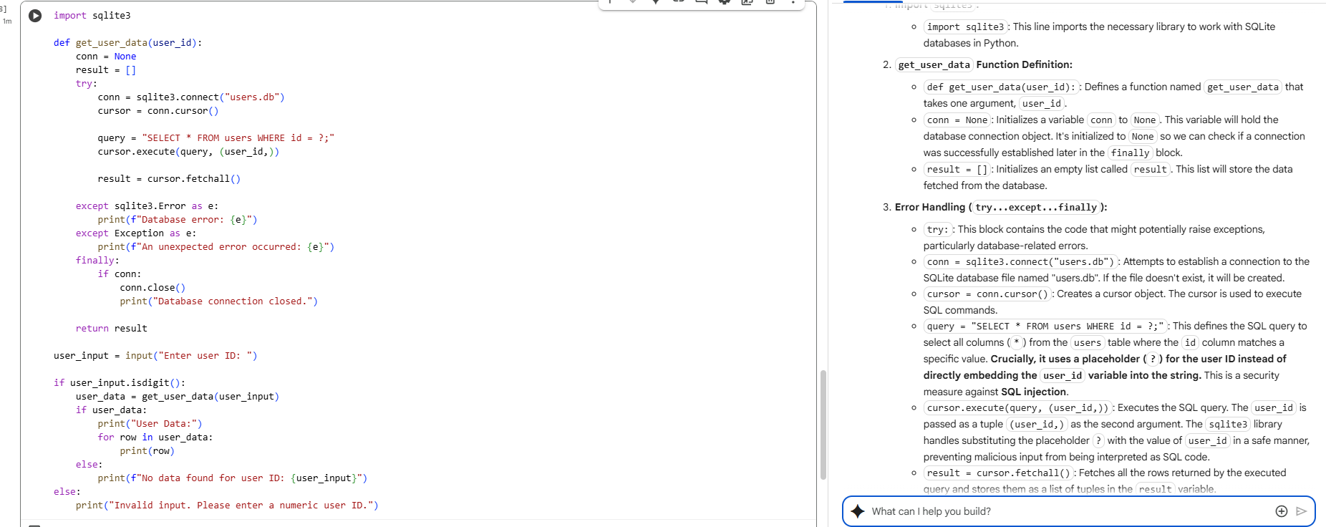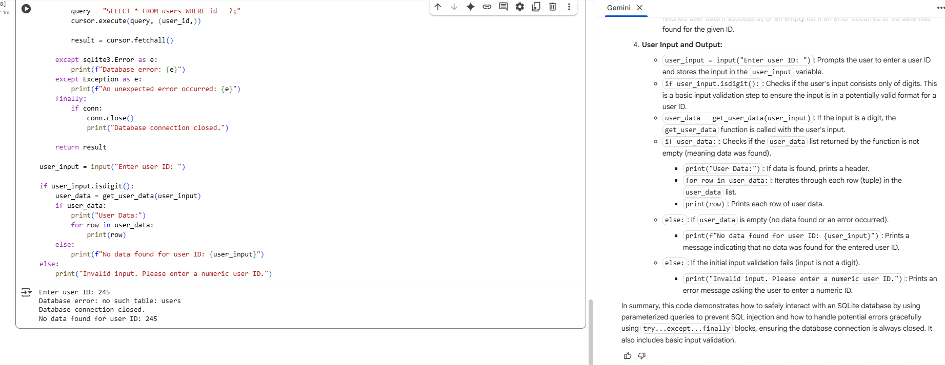

# Task 05

**Task 5: Automated Code Review Report Generation**

x-y

elif z=="mul":

return x*y

elif z=="div":

return x/y **Task**: Generate a **review report** for this messy code.

# buggy_code_task5.py

def calc(x,y,z):

if z=="add":

return x+y

elif z=="sub": return

else: print("wrong")

print(calc(10,5,"add"))

print(calc(10,0,"div"))

**Expected Output**:

AI-generated **review report** should mention:

* + Missing docstrings
  + Inconsistent formatting (indentation, inline return)
  + Missing error handling for division by zero
  + Non-descriptive function/variable names
  + Suggestions for readability and PEP 8 compliance

